

**SRM INSTITUTE OF SCIENCE AND TECHNOLOGY**

**FACULTY OF ENGINEERING & TECHNOLOGY**

(Formerly SRM University, Under Section 3 of UGC Act, 1956)

**S.R.M NAGAR, KATTANKULATHUR – 603 203,**

**KANCHEEPURAM DISTRICT**

**SCHOOL OF COMPUTING**

**DEPARTMENT OF NETWORKING AND COMMUNICATIONS**

**Course Code:** 18CSE305J

**Course Name:** Artificial Intelligence

**Course Project**

**Title: Personality analyzer -** (Resume shortlisting made Easy!)

**Team Members:**

1. Reeti Jha – RA1911030010121
2. SHAMUNESH P – RA1911030010122
3. Sohan Sarkar - RA1911030010126

TABLE OF CONTENTS

TITLE Page No.

1. Objectives …................................................................................................. 3

2. Fieldwork for personality assumptions …...................................................... 4

3. Dependencies of Project …........................................................................... 5

4. Project Description ….................................................................................... 6

5. Implementation ….......................................................................................... 9

6. Code …..........................................................................................................12

7. Test Cases ….................................................................................................16

8. Project Scope ….............................................................................................17

9. Project Pipeline ….......................................................................................... 18

2 | Page

OBJECTIVES

This system can be used in many business parts/areas that may require expert candidates. This system will *reduce the workload* of the (workers in general/hiring, training, and firing department). This system will help  
the (related to workers in general) to *select the right candidate for the desired job profile, which in turn provide the expert* (all the workers in a company or country) for the organization. Admin can easily shortlist  
a candidate based on their personality scores and select the appropriate candidate for a particular job profile.

Using *Natural Language Processing* (NLP) can be defined as a process that enables a machine to become more like a human, because of this deeply cutting the distance between machines and humans. This system  
will focus not only on qualification and inexperience but also focuses on other important aspects, which are needed/demanded for a particular job position. Admin can store the data in excel sheet for further  
comparison and sorting of data

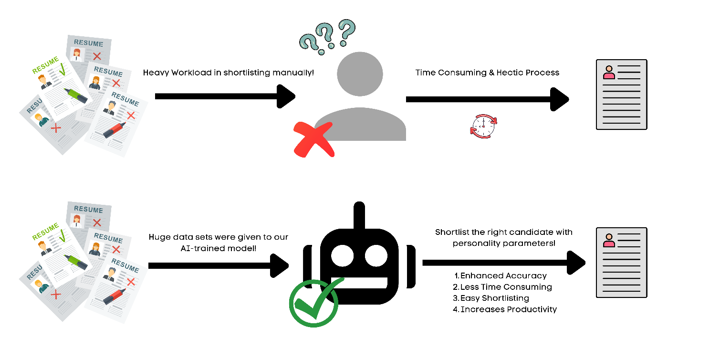

3 | Page

FIELDWORK FOR PERSONALITY ASSUMPTIONS

The Big Five Personality Traits model is based on findings from several independent researchers, and it dates back to the late 1950s. But the model as we know it now began to take shape in the 1990s.

Lewis Goldberg, a researcher at the Oregon Research Institute, is credited with naming the model "The Big Five." It is now considered to be an accurate and respected personality scale, which is routinely used by businesses and in psychological research.  
The Big Five Personality Traits Model measures five key dimensions of people's personalities:

* **Openness**: sometimes called "Intellect" or "Imagination," this measures your level of creativity, and your desire for knowledge and new experiences.
* **Conscientiousness**: this looks at the level of care that you take in your life and work. If you score highly in conscientiousness, you'll likely be organized and thorough, and know how to make plans and follow them through. If you score low, you'll likely be lax and disorganized.
* **Extraversion/Introversion**: this dimension measures your level of sociability. Are you outgoing or quiet, for instance? Do you draw energy from a crowd, or do you find it difficult to work and communicate with other people?
* **Agreeableness**: This dimension measures how well you get on with other people. Are you considerate, helpful and willing to compromise? Or do you tend to put your needs before others'?
* **Natural Reactions**: sometimes called "Emotional Stability" or "Neuroticism," this measure emotional reactions. Do you react negatively or calmly to bad news? Do you worry obsessively about small details, or are you relaxed in stressful situations?

4 | Page

DEPENDENCIES OF PROJECT

**Python Modules/Libraries:**

1. **OS**: For accessing the files and data from internal storage.  
2. **Pandas**: For accessing and manipulating datasheets.  
3. **Numpy**: For working on arrays and other data manipulation.  
4. **Tkinter**: For building the GUI.  
5. **Functools**: Tools for Manipulating Functions. Purpose: Functions that operate on other functions.  
6. **Pyresparser**: Module for extracting information from resume.  
7. **Sklearn**: It features various classification, regression and clustering algorithms. We used sklearn to make the model learn on various characteristic values using logical regression.

5 | Page

DESCRIPTION

The system built in this project predicts personality of peoples by using their gender, age, score of openness, conscientiousness, extraversion, agreeableness, neuroticism and experience. It parses all the data from CV/resume and on the result page, it shows all the information from the entered data and uploaded resume.  
This system uses logistic regression for training the model and pyresparser module for parsing the information from resume which is built using nltk and spaCy module in python.

**Description of Methods and Flow in the System:**  
 1. **train_model class**: It contains two method which train the model and predict the result by giving the various values.  
 a. **train method**: It read the dataset for training the model from a csv file and build a model using Logistic Regression. It uses different 7 values for training the model.

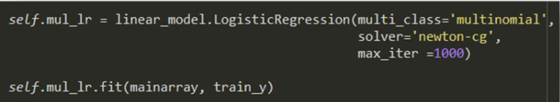

b. **test method**: It predict the personality of a person by passing an array of values that contains gender, age and other 5 personality characteristics.

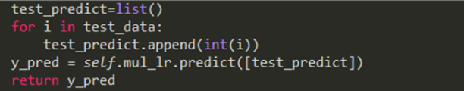

2. **main method**: We start with creating an object of *train_model* class and train the model by calling train method of class. Then we initialize a variable with Tk object and design the landing page of system using labels and button. A button with name Predict Personality is designed which calls *predict_person* method.

6 | Page

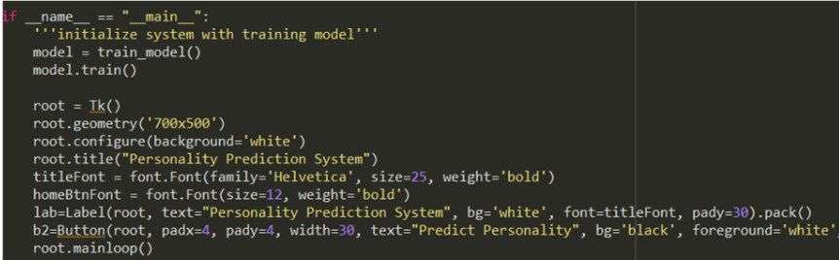

3. **predict_person method**: We withdraw the root *tkinter* window and create a new *toplevel* window and configure its size and attributes. We label the heading of window followed by various labels and their entries. For selecting of a resume file, user needs to press choose file button which then calls *Openfile* method that takes an argument of button. In *predict_person* method, various entries are  
taken for predicting the personality. Submit button pass all the values to *prediction_result*.

4. **OpenFile method**: It tries to open the directory with default address name and file types and except if file not chosen. After try except block, the method changes the name of choose file button in *predict_person* method with the base name of file so that user can know about the chosen file.

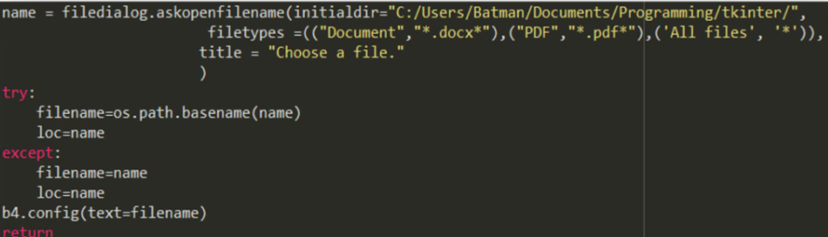

7 | Page

5. **prediction_result method**: This method firstly closes the previous *tkinter* window which was used to take the data from user. After this, it calls test method of model object and stores the result returned by method. After this it parse all the information from resume and stores in a variable followed by a try except block which try to delete name and validate mobile number from fetched information from resume. Then it prints all the data submitted by user on console. After this, the method popup a full screen window which shows all the parsed information and predicted personality on GUI window along with the definition of each personality characteristic’s definition.

6. **check_type method**: It converts various strings and numbers into desired format and converts lists and tuples in string.

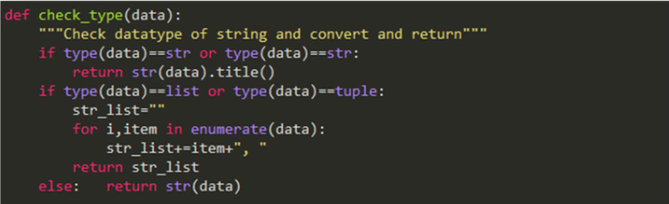

8 | Page

IMPLEMENTATION

On landing page, *‘Predict Personality’* button pops up a new window for taking various inputs from user and submit it prediction model which will predict the personality.

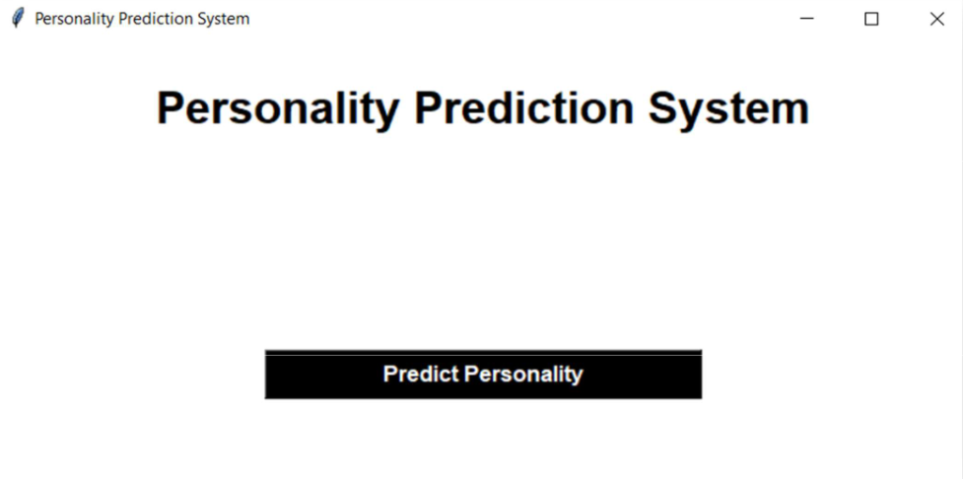

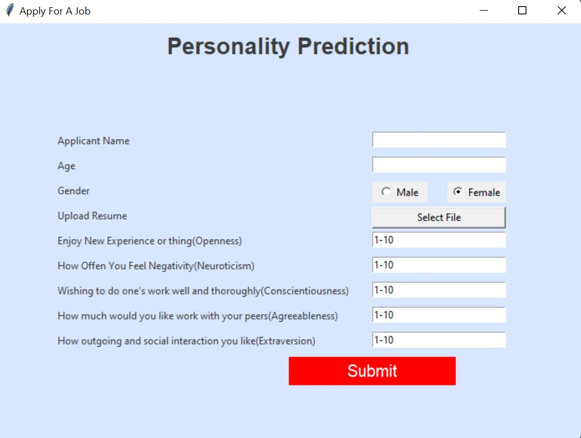

9 | Page

On, result page, all the manipulated information and predicted result will be displayed.

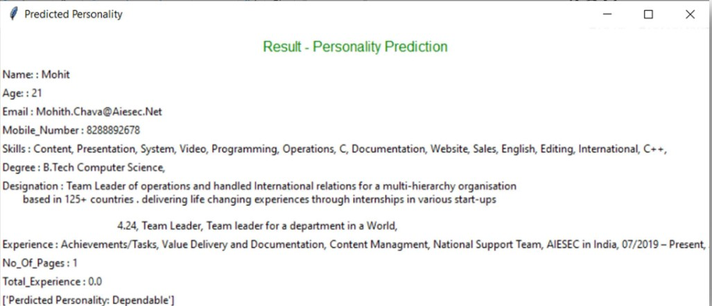

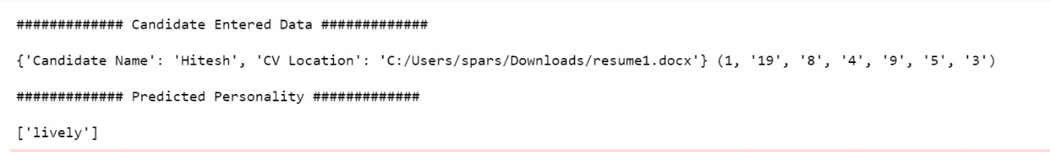

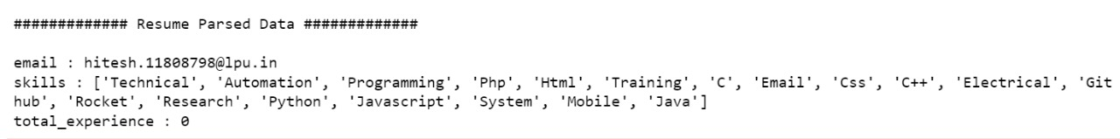

10 | Page

CODE

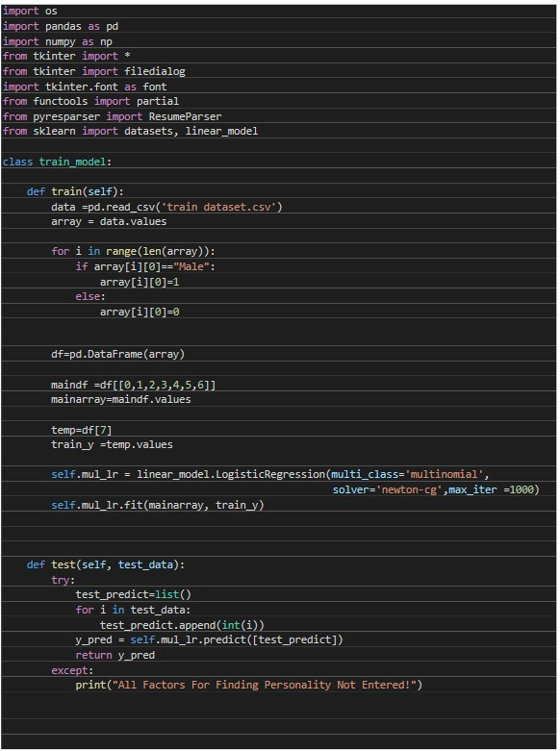

11 | Page

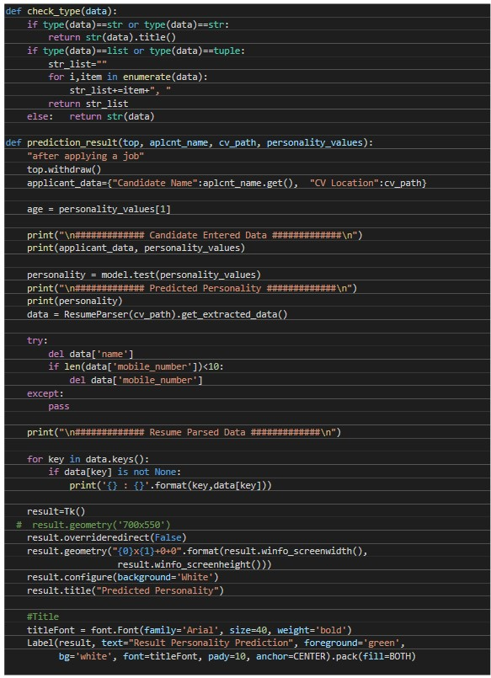

12 | Page

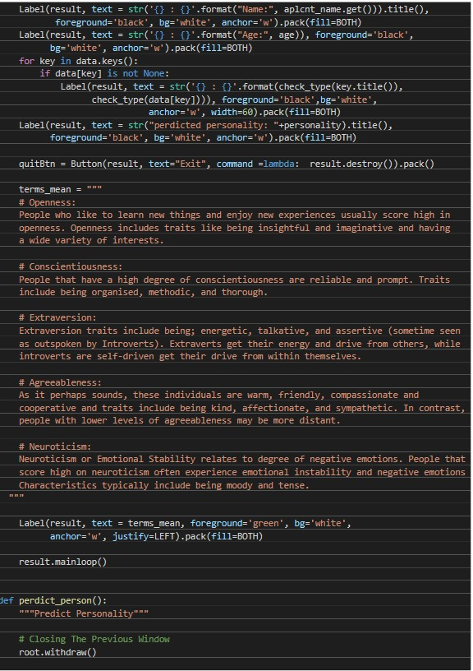

13 | Page

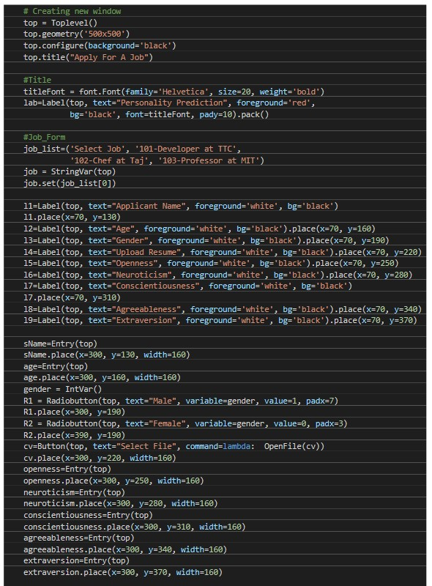

14 | Page

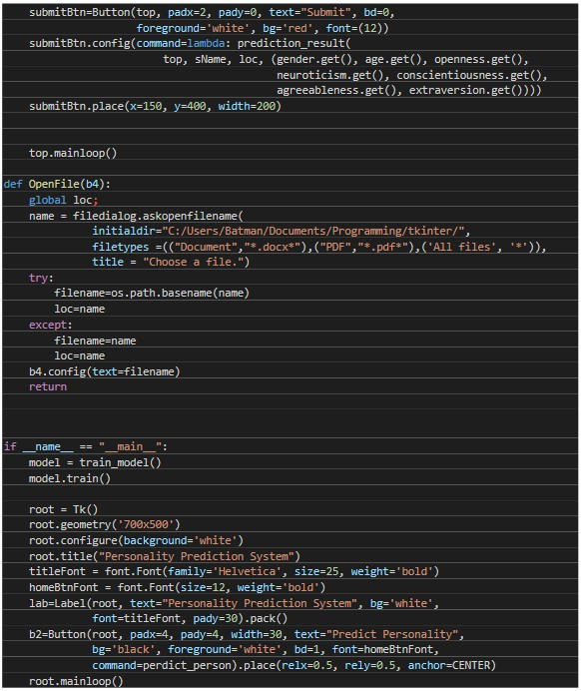

15 | Page

TEST CASES

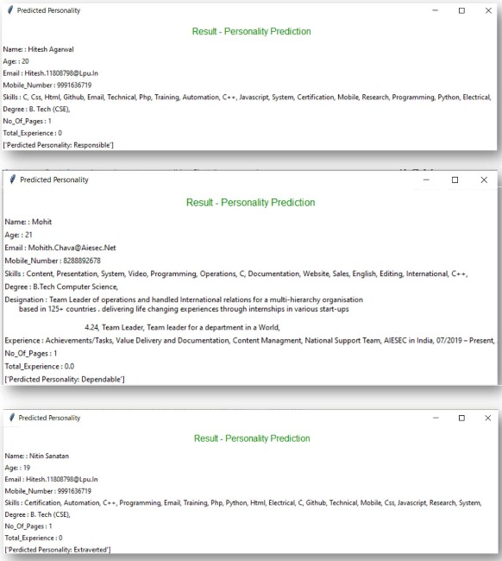

16 | Page

PROJECT SCOPE

**Strengths:**

* Interactive and easy to use.
* Extract all the important features of resume in seconds
* Easily predict the personality of applicant.

**Opportunities:**

* It can be extended for commercial uses
* It can be made more interactives where we can easily handle bulk data and represent it.
* It can improve the training model for various addition features that help us to predict more accurate result.
* Instead of direct asking the five characteristic values we can add questionaries’ which ask some multiple-choice questions and auto calculate the various values.

17 | Page

PROJECT PIPELINE (DEVELOPMENT)

|  |  |  |
| --- | --- | --- |
| **S.no** | **Task** | **Assignee** |
| 1. | Research / Fieldwork | Shamunesh P, ReetiJha |
| 2. | Design and Requirements | Sohan Sarkar |
| 3. | Project Development (Python env) | Reeti Jha, Shamunesh P, Sohan Sarkar |
| 4. | Documentation | Sohan Sarkar, Shamunesh P |

Github Link:

https://github.com/Sohan11Sarkar/Personality-Prediction-Through-CV

18 | Page